**Chapter 1**

**INTRODUCTION TO HTML**

**HTML** :- HTML is the standard markup language for creating web pages .

* HTML stands for Hyper Text Markup Language
* HTML describes the structure of pages using markup
* HTML elements are the building blocks of HTML pages.
* HTML element are represented by tags.
* HTML tags label pieces of contain such as "heading", "paragraph", "table", and so on.
* Browsers do not display the HTML tags, but use them to render the content of the page.

**Example :-**

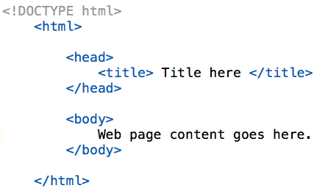

**Fig 1.1:- Screenshot of HTML**

**9**

**Chapter 2**

**INTRODUCTION TO CSS**

**CSS-** CSS is '**cascading style sheets**' it is used to style the web pages

* CSS describe how HTML elements are to be displayed in screen, paper, or in other media
* CSS saves a lot of work. it can control the layout of multiple web pages all at once
* External style sheets are stored in CSS files.

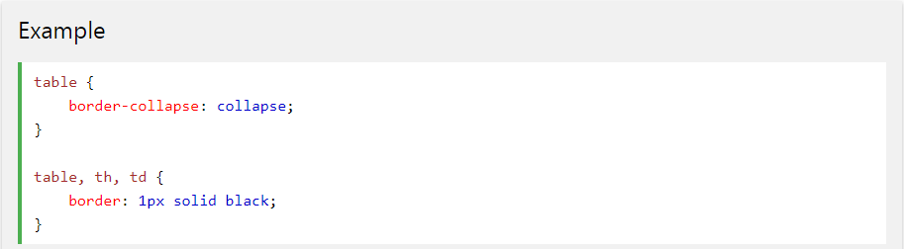

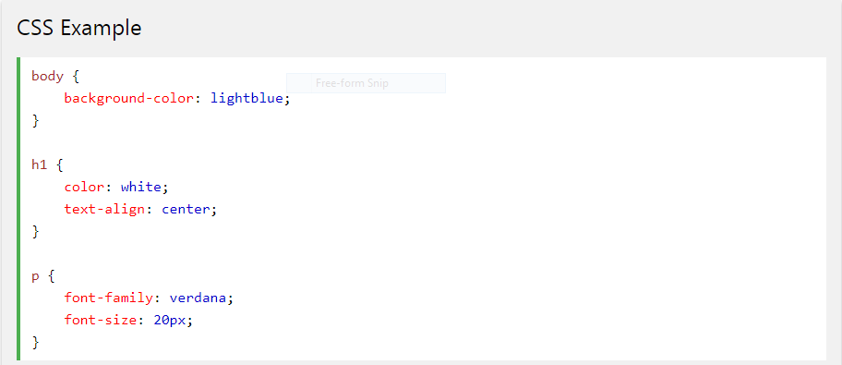 **Fig 2.1:- Screenshot of CSS**

**A Fig 2.2:- Screenshot of CSS**

**10**

**Chapter 3**

**INTRODUCTION TO BOOTSTRAP**

**Bootstrap**-Bootstrap is the most popular HTML, CSS, and JAVASCRIPT framework for

developing responsive, mobile-first websites.

**Feature of bootstrap-** There are many feature of bootstrap some of them are:-

* Easy to use
* Responsive feature
* Consistent design
* Mobile first approach
* Browser compatibility

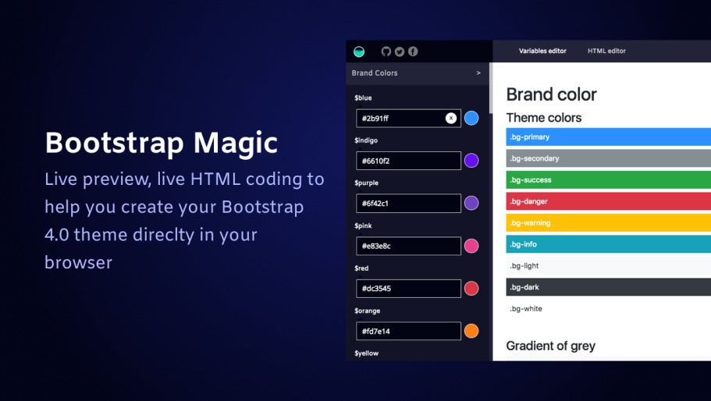

**Fig 3.1:- Screenshot of Bootstrap**

**11**

**Brief introduction to project**

**My project name**- Foodies.com

**Description**-

* My project is based on FOOD SERVICE which provides all the facilities Regarding FOOD and RESTAURANT in beautiful cities like Agra, Delhi, Lucknow,Gurugram and others
* I have used the bootstrap to design user interface, which make the website more attractive and more presentable.
* I have used a little bit of CSS language to design some internal parts of the website.
* My project contain web pages are:-

1. **HOME**
2. **ABOUT US**
3. **CONTACT US**
4. **LOGIN/SIGNUP**

**Software requirement:-**

1. **Windows 7 or higher version**
2. **VS code**

**12**

SCREENSHOTS OF WEBSITE:-



**Fig 4.1:- Screenshot of website**

**13**

**DESIGN OF SOLUTIONS**



**Fig 5.1:- Screenshot of Home page**

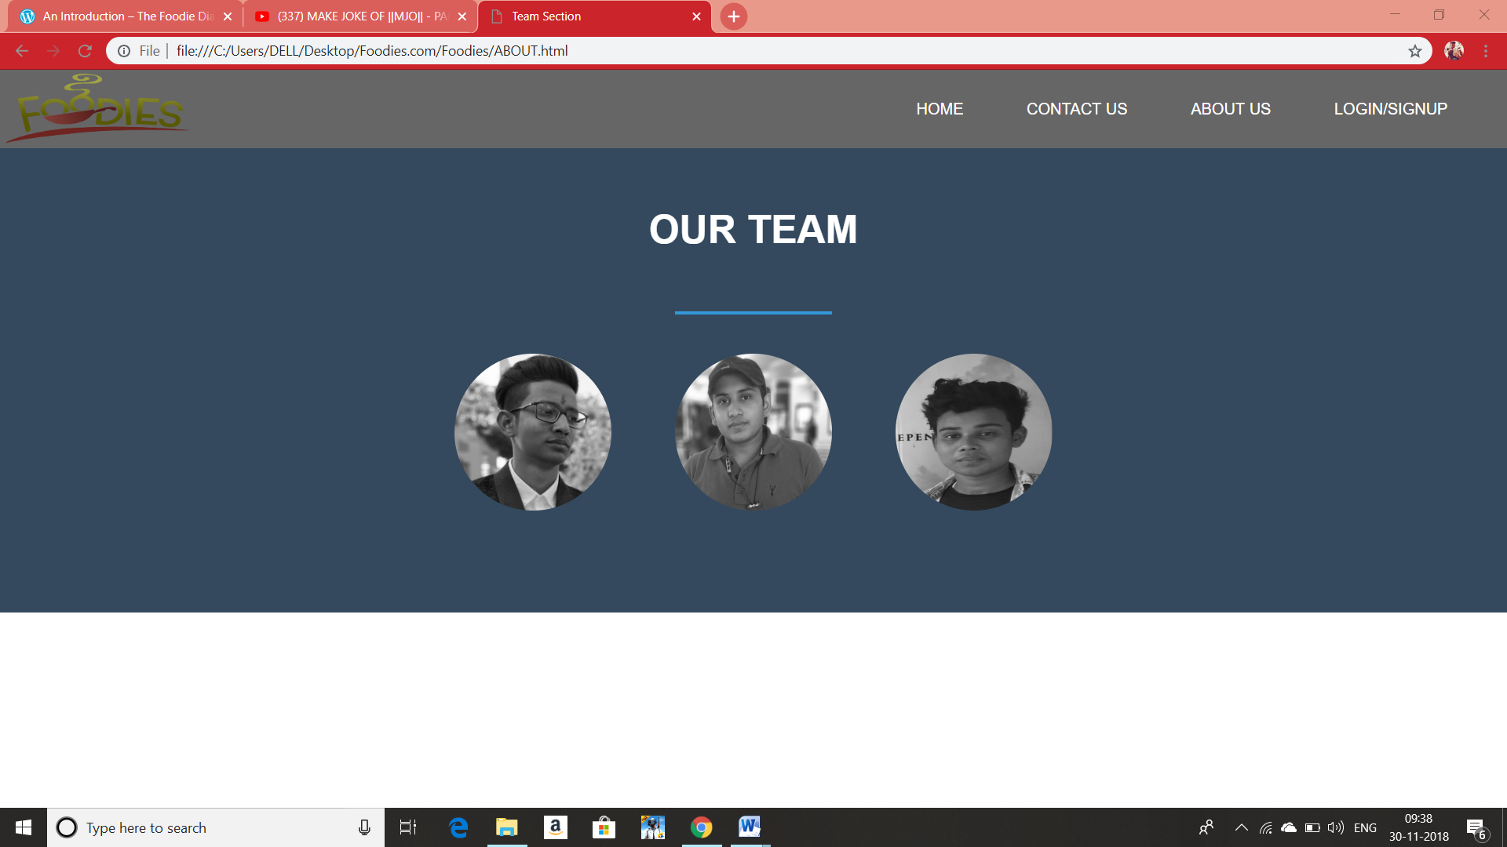

**Fig 5.2;- Screenshot of About us page 14**

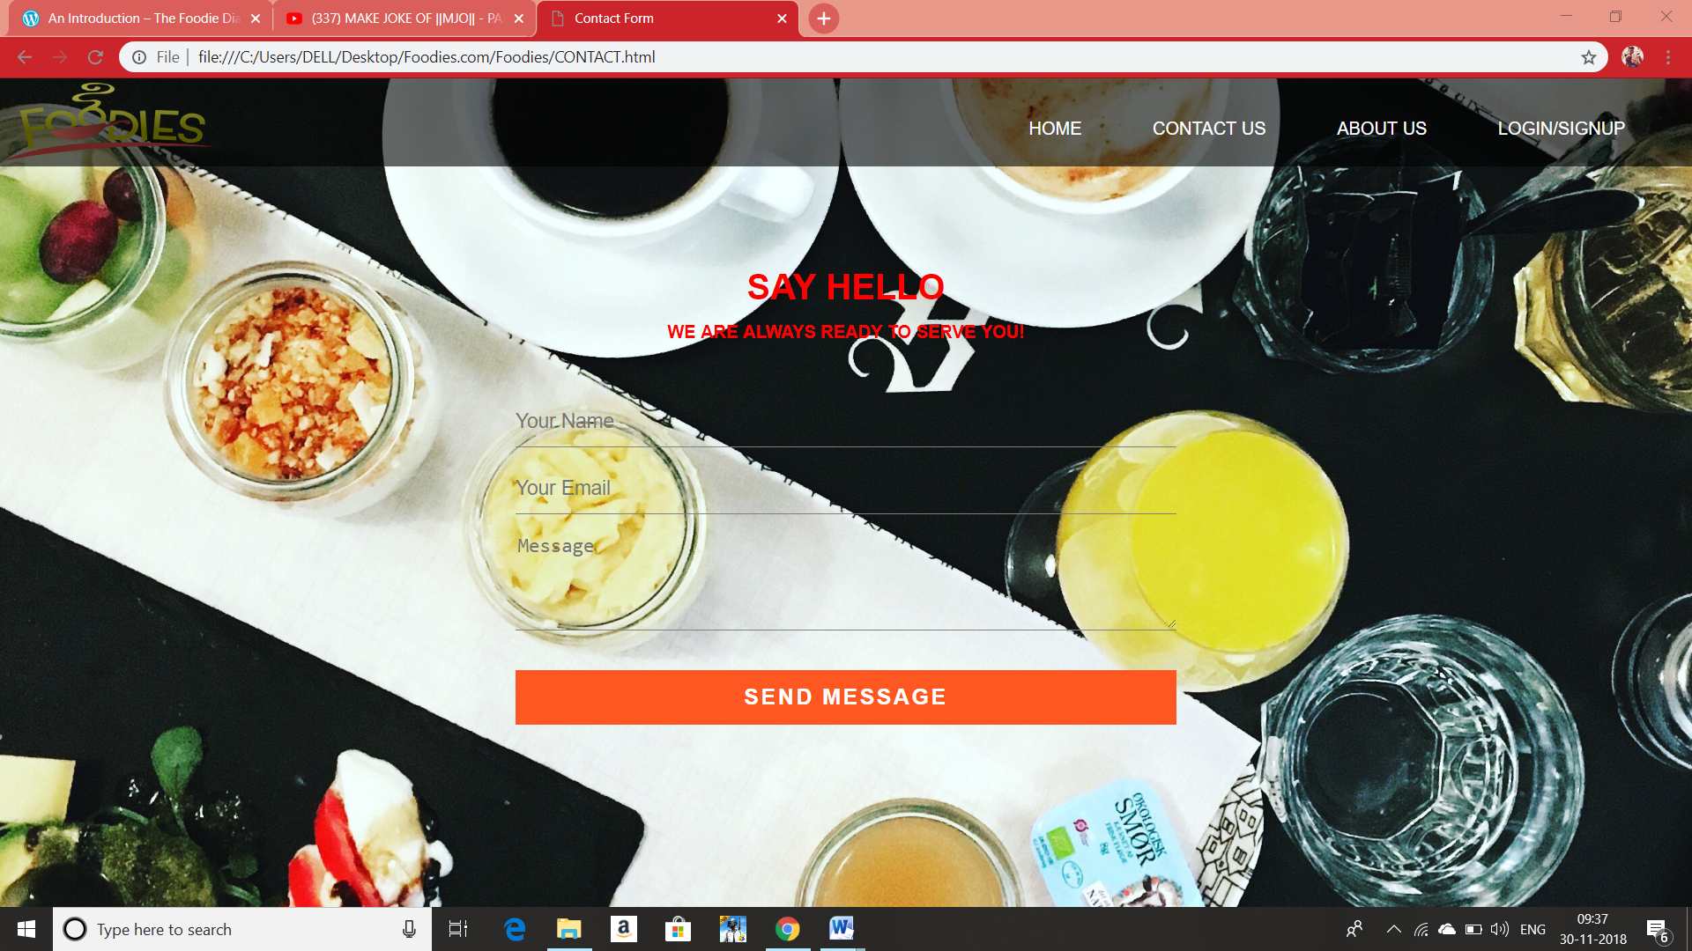

**Fig 5.3:- Screenshot of Contact us page**

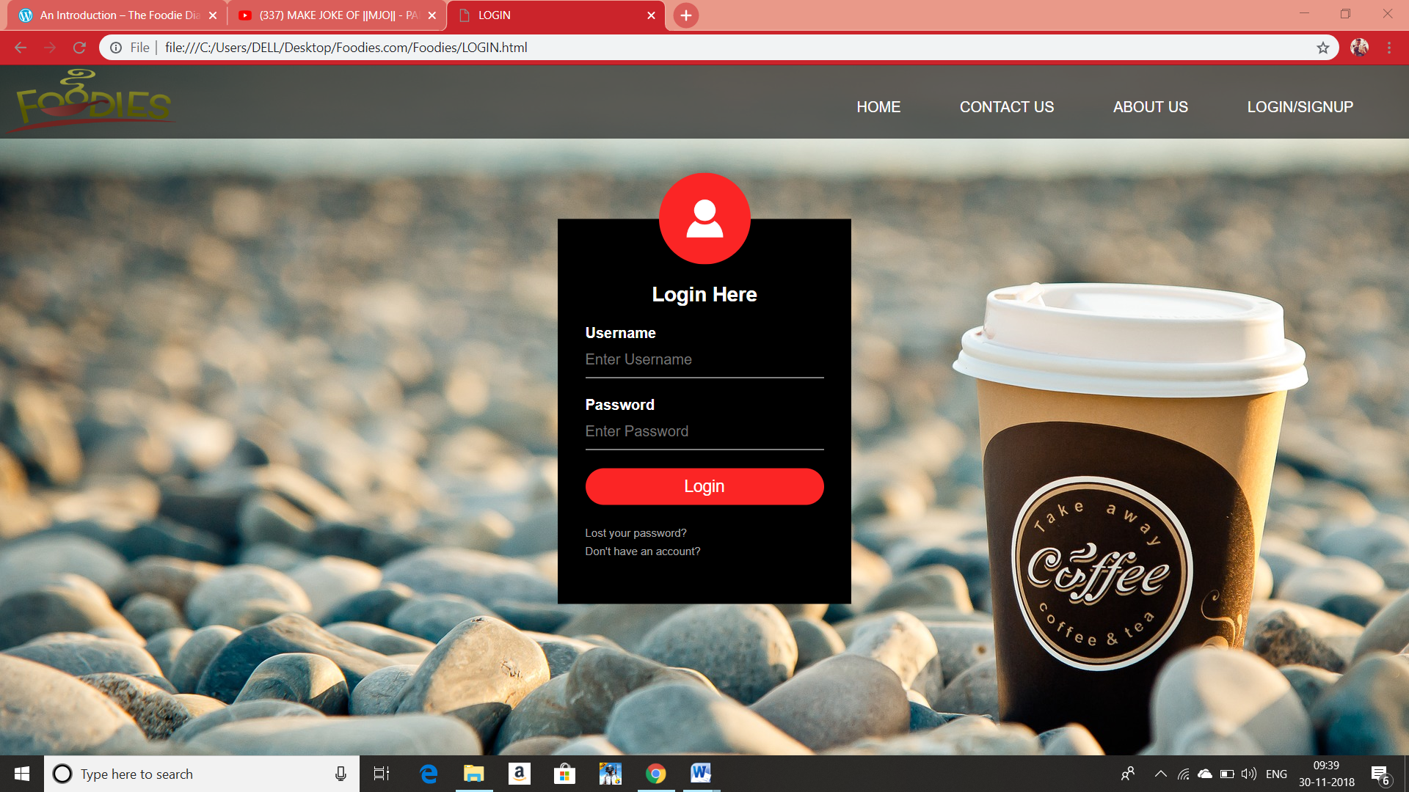

**15 Fig 5.4:-Screenshot of login page**

**Methodology/ Planning of work/ Details of project**

**Home page coding**:-

<html>

<head>

<title>Foodies.com</title>

<link rel="stylesheet" type="text/css" href="HOME.css">

</head>

<body>

<div class="navi">

<nav>

<img src="logo.png" width="200" height="80">

<ul>

<li><a href="HOME.html">HOME</a></li>

<li><a href="CONTACT.html">CONTACT US</a></li>

<li><a href="ABOUT.html">ABOUT US</a></li>

<li><a href="LOGIN.html">LOGIN/SIGNUP</a></li>

</ul>

</nav>

</div>

</body>

</html>

16

**Output:-**

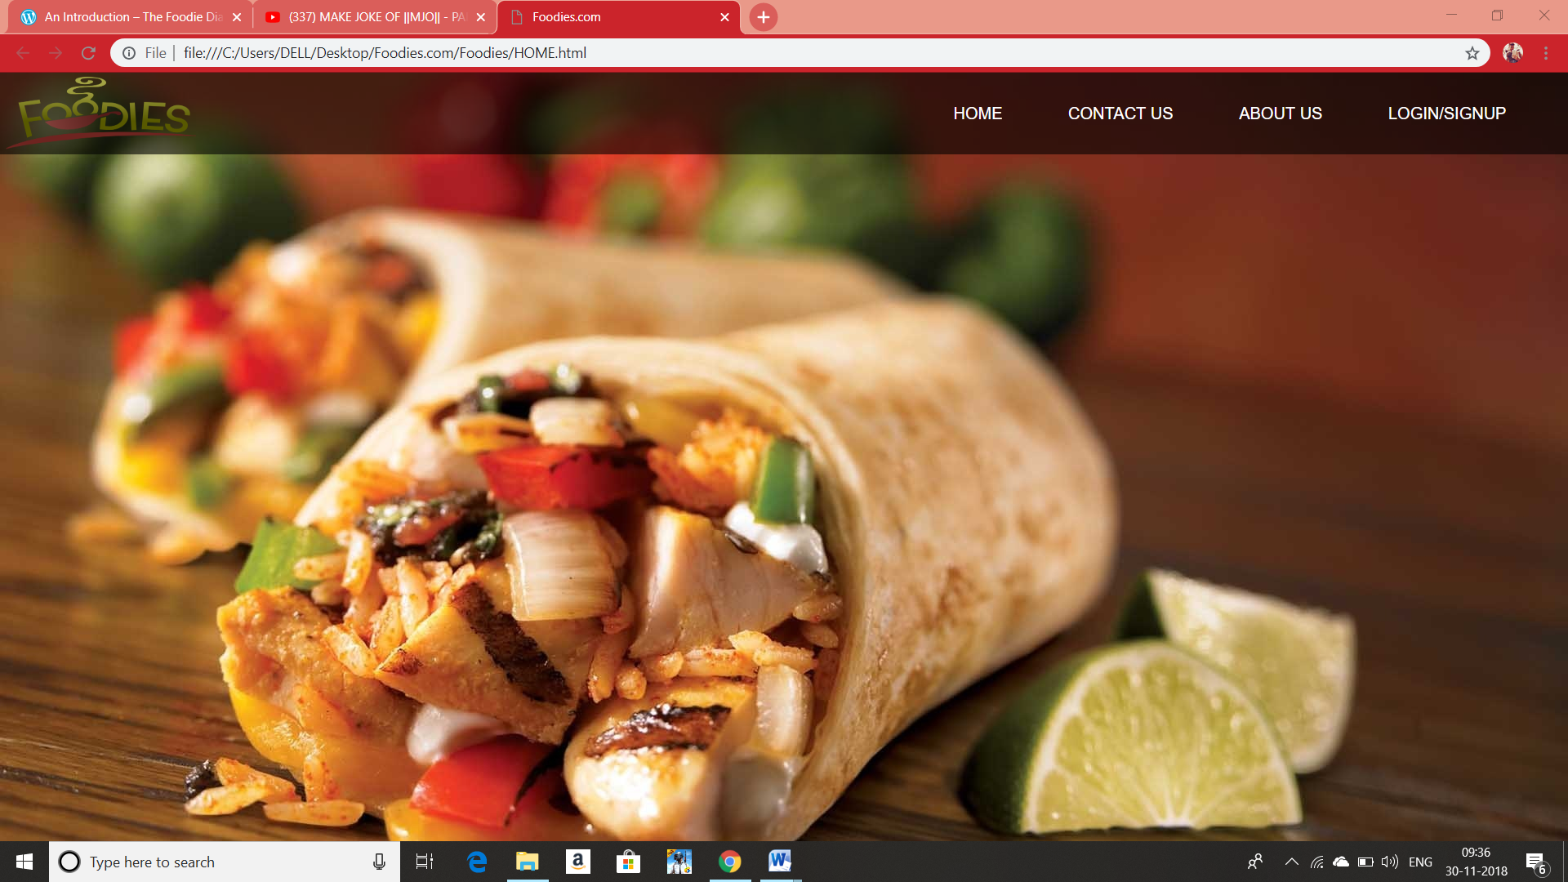

**Fig 6.1:- Screenshot of Home page**

17

**About us coding**:-

<!DOCTYPE html>

<html>

<head>

<meta charset="utf-8">

<title>Team Section</title>

<link rel="stylesheet" type="text/css" href="ABOUT.css">

</head>

<body>

<div class="navi">

<nav>

<img src="logo.png" width="200" height="80">

<ul>

<li><a href="HOME.html">HOME</a></li>

<li><a href="CONTACT.html">CONTACT US</a></li>

<li><a href="ABOUT.html">ABOUT US</a></li>

<li><a href="LOGIN.html">LOGIN/SIGNUP</a></li>

</ul>

</nav>

</div>

<div class="team-section">

<h1>Our Team</h1>

<span class="border"></span>

<div class="ps">

<a href="#p1"><img src="p1.jpg" alt="" height="180px" width="150px"></a>

<a href="#p2"><img src="p2.jpg" alt="" height="180px" width="150px"></a>

<a href="#p3"><img src="p3.jpg" alt="" height="180px" width="150px"></a>

</div>

<div class="section" id="p1">

<span class="name">Vikrant Pratap Singh</span>

<span class="border"></span>

<p>

Coder and web site desiner

</p>

</div>

<div class="section" id="p2">

<span class="name">Shivanshu Pandey</span>

<span class="border"></span>

<p>

Data collector and research

</p>

</div>

<div class="section" id="p3">

<span class="name">Nalla</span>

<span class="border"></span>

<p>

### UI Designer

</p>

</div>

</div>

</body>

</html>

18

**Output:-**

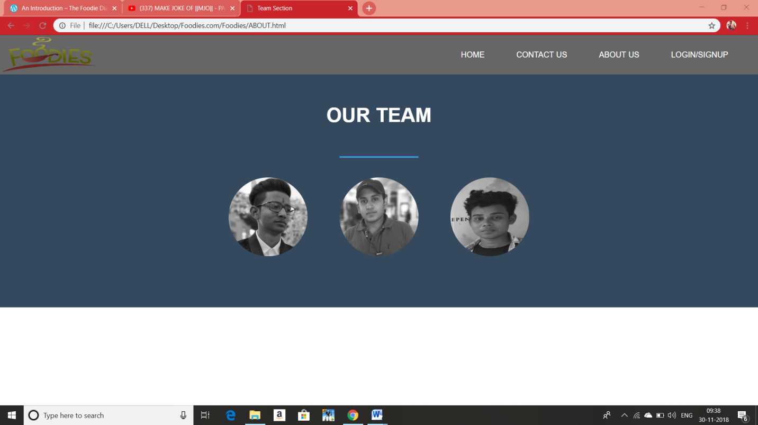

**Fig 6.2:- Screenshot of About us page**

**19**

**Contact us:-**

<html>

<head>

<title>Contact Form</title>

<link rel="stylesheet" type="text/css" href="CONTACT.css">

</head>

<body>

<div class="navi">

<nav>

<img src="logo.png" width="200" height="80">

<ul>

<li><a href="HOME.html">HOME</a></li>

<li><a href="CONTACT.html">CONTACT US</a></li>

<li><a href="ABOUT.html">ABOUT US</a></li>

<li><a href="LOGIN.html">LOGIN/SIGNUP</a></li>

</ul>

</nav>

</div>

<div class="contact-title">

<h1>Say Hello</h1>

<h2>We are always ready to serve you!</h2>

</div>

<div class="contact-form">

<form id="contact-form" method="POST" action="">

<input name="name" type="text" class="form-control" placeholder="Your Name" required><br>

<input name="email" type="email" class="form-control" placeholder="Your Email" required><br>

<textarea name="message" class="form-control" placeholder="Message" rows="4" required></textarea><br>

<input type="submit" class="form-control submit" value="SEND MESSAGE">

</form>

</div>

</body>

</html>

**20Output:-**



**Fig 6.3:- Screenshot of Login page**

**21**

**Log in page coding:-**

<html>

<head>

<title>LOGIN</title>

<link rel="stylesheet" type="text/css" href="LOGIN.css">

</head>

<body>

<div class="navi">

<nav>

<img src="logo.png" width="200" height="80">

<ul>

<li><a href="HOME.html">HOME</a></li>

<li><a href="CONTACT.html">CONTACT US</a></li>

<li><a href="ABOUT.html">ABOUT US</a></li>

<li><a href="LOGIN.html">LOGIN/SIGNUP</a></li>

</ul>

</nav>

</div>

<div class="loginbox">

<img src="avatar.png" class="avatar">

<h1>Login Here</h1>

<form>

<p>Username</p>

<input type="text" name="" placeholder="Enter Username">

<p>Password</p>

<input type="password" name="" placeholder="Enter Password">

<input type="submit" name="" value="Login">

<a href="#">Lost your password?</a><br>

<a href="REGISTER.html">Don't have an account?</a>

</form>

</div>

</body>

</html>

**22**

**Output:-**



**Fig 6.4:- Screenshot of Login page**

23

**Figures and Tables**

|  |  |  |
| --- | --- | --- |
| **FIGURE** | **TITLE** | **PAGE NO.** |
| Fig1.1 | Introduction to HTML | 1 |
| Fig2.1  Fig2.2 | Introduction to CSS | 2 |
| Fig3.1 | Introduction to Bootstrap | 3 |
| Fig4.1 | Brief introduction to project | 5 |
| Fig5.1  Fig5.2 | Design  of  solution | 6 |
| Fig5.3  Fig5.4 | 7 |
| Fig6.1  Fig6.2  Fig6.3  Fig 6.4 | Methodology/ Planning of work/ Details of project | 9  11  13  15 |

8

FOODIES.COM

**REPORT**

SUBMITTED IN PARTIAL FULFILLMENT OF THE REQUIREMENT FOR

Minor Project in Training

at

**SAITM, Gurgaon**

**(from 20thAug to Nov 2018)**

SUBMITTED BY

Shivanshu pandey

BCA

5007814



**BACHELORS IN COMPUTER APPLICATION DEPARTMENT**

**St. Andrews Institute of Technology and Management**

Farrukhnagar, GURUGRAM

1

**St. Andrews Institute of Technology & Management farrukhnagar, Gurugram**

**TO WHOM IT MAY CONCERN**

I hereby certify that “SHIVANSHU PANDEY” Roll No 5007814 of St.Andrew’s Institute of Technology and Management, Gurgaon, has undergone training from 20TH AUGUST 2018 to 19th NOVEMBER to 2018 at our College to fulfill the requirements for the award of degree of BCA. He works on Foodies.com project during the training under the supervision of Piyush Pandey During his tenure with us we found him sincere and hard working.

Wishing him a great success in the future.

Signature of the Student

Signature of the Director (S) Signature of the HOD (S)

 (Seal of Organization)

2

**ACKNOWLEDGEMENT**

The authors are highly grateful to the Dr. Jugnesh, Director, St.Andrew’s Institute of Technology and Management, Gurgaon, for providing this opportunity to carry out the Summer Internship training at SAITM.

The constant guidance and encouragement received from Director T&P, SAITM, Gurgaon, has been of great help in carrying out the project work and is acknowledged with reverential thanks.

The authors would like to express a deep sense of gratitude and thanks profusely to PIYUSH PANDEY SIR. Without the wise counsel and able guidance, it would have been impossible to complete the report in this manner.

The help rendered by [Faculty In charge of Training], Supervisor (PIYUSH PANDEY SIR) for experimentation is greatly acknowledged.

The author express gratitude to other faculty members of Computer Science Engineering department of SAITM for their intellectual support throughout the course of this work.

Finally, the authors are indebted to all whosoever have contributed in this report work and friendly stay at St. Andrews Institute Of Technology And Management .

(shivanshuspandey)

**3**

**ST. ANDREWS INSTITUTE OF TECHNOLOGY & MANAGEMENT GURGAON**

**MAY-JULY, 2018**

**BONAFIDE CERTIFICATE**

This is to certify that the project entitled **Foodies.com** is the bonafide record of project work done by Mr. **Shivanshu pandey** URN**: 5007814** of BCA/1st Year during the year **2018.**

**Signature of the Signature of**

**HOD PROJECT GUIDE**

4

**DECLARATION**

I affirm that the project work titled **Foodies.com** being submitted in partial fulfillment for the award of the degree of BCA is the original work carried out by me. It has not formed the part of any other project work submitted for award of any degree or diploma, either in this or any other University.

**Signature of the Candidate**

Shivanshu pandey

5007814

I certify that the declaration made above by the candidate is true.

**Signature of the Guide**

Piyush Pandey

St. Andrews

Institution of Technology and

Management

**5**

**DECLARATION**

I affirm that the project work titled **Foodies.com** being submitted in partial fulfillment for the award of the degree of BCA is the original work carried out by me. It has not formed the part of any other project work; submitted for award of any degree or diploma, either in this or any other University.

**Signature of the Candidate**

Shianshu pandey

URN: - 5007814

I certify that the declaration made above by the candidate is true.

**Signature of the Guide**

Mr.Piyush Pandey

Trainer

**6**

**TABLE OF CONTENTS**

**CHAPTER No. TITLE PAGE No.**

**List of figures 8**

1. **Introduction to HTML 9**
2. **Introduction to CSS 10**

**3 Introduction to Bootstrap 11**

**Brief introduction to project 12-13**

**Design of Solution 14-15**

**Methodology/ Planning of work 16-23**

**/Details of project**

**Conclusion 24**

**Reference 25**

**7**

**Conclusion**

It is a modern website to provide food service and Restaurant in various place in India like Agra, Mathura, Lucknow etc. Creating a website for services like this will always increases your business and profits and provide ease to order food and enjoy the whole process.

This website has been created by using language HTML and CSS we have used Bootstrap also in designing part for front-end to make it more attractive and presentable.

This website contain Home page, contact page, Join us page, and about us page.

**24**

**Reference**

* [**www.w3schools.com**](http://www.w3schools.com)
* [**www.getbootstrap.com**](http://www.getbootstrap.com)
* [**www.youtube.com**](http://www.youtube.com)

25